**Lab 1**

1. **A)**

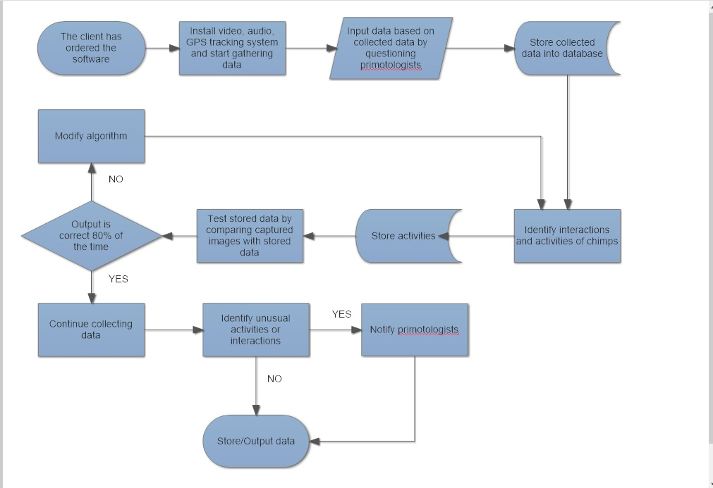

The client has ordered software which will study the details of daily activities and interactions of 6 chimpanzees. Software will be designed to gather video and audio activities of chimps and will identify each activity or interaction by captured images, video and sounds. Also program will notify primatologists if any unusual activity is noticed (ex. Chimp did not eat for the whole day, not moved for a long time, acting too aggressively to other chimps, etc.).

* First in order to “bar-code” each chimp GPS bracelets (tracking system) needs to be installed.
* Install video, audio and GPS tracking system in order to gather data
* Work with primatologists in order to identify each interaction which was recorded.
* Store data that was collected from primatologists (add specifications for each movement done by chimps)
* Software will try to identify each interaction and activity in real time (ex. Will capture the image, save time of the event and add description stating what chimps are doing at the moment)
* After storing the data the software will be tested for correctness. The recordings will be shown to the primatologists together with the results of the activity identification.
* If output is correct at least 80% of time, continue recording and identifying activities by adding some extra features, if output is not correct at least 80% of the time the algorithm will need to be modified and more specifications would be added to help software identify chimps activities more accurately.
* If any unusual activity is noticed primatologists will be notified immediately (chimp is not moving, not eating etc.)
* Store all gathered data and outputs.

**B)**

odd_man_out (input array numbers)

temp <- number[0];

for each element i in the array of numbers

temp <- temp XOR numbers[i];

endfor

return temp;